WEEK 6:
Accounts:
- Fundamental building block of the accounting system that helps builds the financial statement
- Asset accounts:
- Represent recources owned or controlled by the business
- Cash/accounts receivables/inventory/equipment/buildings
- Liabilities account
- Represent obligations or debts the business ows to others.
- Something the business has topay in future
- Accounts payable/loans payable/salaries payable/taxes payables
- Equity accounts:
- Represent the owners claim or ownership interest on the business
- Owners capital – own money/retained earnings – profit/drawings – owners withdrawals – not an expense
- Revenue accounts:
- Records the income the business earnes – any revenue generated
- Sales revenue/service revenue/interest income
- Expense accounts:
- Represent costs incurred to run the business and generate revenue
- Rent expense/salaries expense/advertising expense/utilities expense
- Profit – revenue – expense
Rules of accounting:
- Debit – when you get something
- Credit – when you give something
- Debit what comes in, credit what goes out
- Debit the receiver, credit the giver
- Debit all expenses/losses, credit all incomes and gains
Investing capital – cash debit ; capital credit
Taking loan – cash a/c – debit ; credit bank which gives loan
Buys equipment - debit equipment ; cash credited (cash goes out)
Withdraw money for personal use: credit cash going out ; debit the receiver (person)

Fundamental accounting equation:
- Assets = liabilities + equity(capital)
- Assets – resources owned by business – cash / inventory
Liabilities – obligations to outside parties – loans / payables
Equity residual interest or the owners claim on assets after all liabilities are paid
Inventory:
- Goods/materials that a business holds for the purpose of selling to customers or using in production
- Considered as a current asset.
COST OF GOODS SOLD:
COGS = Opening inventory + purchase – closing inventory
Closing inventory is a current asset
Valuation of inventory:
- FIFO – accounting method where assets purchased first are disposed of first.
- LIFO – most recently produced items sold first.
- Weighted average – cost of all units available for sale is averaged and this cost is used to value.
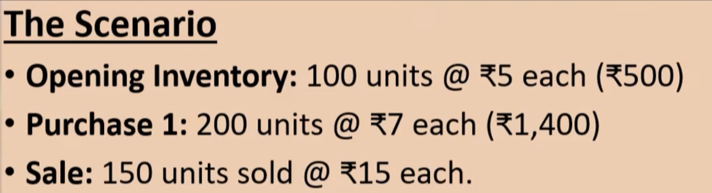

Depreciation:
Reduction in the value of fixed assets due to wear and tear or obsolescence over time.
treated as indirect expense

Financial Statements:
Formal records that consolidate financial activities.
- Income statement:
Denotes performance of business.
Finds the profit/loss: expense – revenue

- Balance sheet:
Depicts the financial position of the company on a specific date (usually last day of accounting year).
Basically tells us about assets: assets = liabilities + equity

- Cash flow statement:
Tracks movement of cash :
Net change in cash = operating + investing + financing
Income statement:
- Trading account:
  - Credit side: incomes derived from the primary business of the company. – sales + closing stock
  - Debit side: expenses tied to the production of the organization.
  - Gross profit: difference between credit and debit sides --- this is the result of trading account
- Profit and loss account:
  - Credit side: indirect incomes - gross profit
  - Debit side: indirect expenses – expenses necessary to run the business
  - Result: after reducing interest and tax the final balancing figure is the Net Profit after Tax – added to the owners’ capital.
Balance Sheet:
- Liability and capital side - sources of fund
  - Equity capital/reserves and surplus/short term/long term liabilities
- Assets side – application of funds:
  - Fixed/current assets
Cash flow statement:
- Operating activities
  - Business does in order to execute its primary operations – revenue generated from the company’s core operations
  - Cash received from customers/cash paid to suppliers/salaries
- Investing activities
  - Buying and selling long term assets used in the business
  - Purchase of equipment/sale of land/investments into other companies
- Financial activities
  - Related to raising money and repaying funds
  - Issuing shares/borrowing from banks/repayment of loans

